HIGHLIGHTS OF
THE FIRST 40 YEARS
OF THE BAHÁ’Í FAITH
IN NEW YORK,
CITY OF THE COVENANT 1892-1932

Compiled by Hussein Ahdieh.

The information compiled in this document was made available to me by The Local Spiritual Assembly of the Bahá’ís of New York City
while working on the booklet
honoring the Seventy-Fifth Anniversary
of ‘Abdu’l-Bahá’s trip to New York City.
Other sources include materials from
The Star of the West,
Robert Stockman’s books

with the diaries of Mirza Mahmud-i-Zarqani of Persia and Juliet Thompson of America.

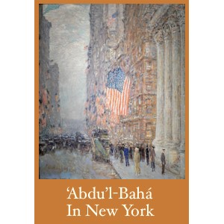

The summary of highlights of significant events in the Bahá’í history of New York City is not meant to be a complete review of the period. However, by including a variety of significant events in this collection, we hope the reader will have an increasing appreciation for the many serendipitous happenings and inter-connections of a handful of sincere seekers, whose dedication, systematic proclamations, persistence and steadfastness to the Cause established the Bahá’í Faith in New York. How very fortunate they were to have visited both the Master and the Guardian in Haifa, as well as to have had ‘Abdu’l-Bahá visit New York 100 years ago.

We have included highlights of historical markers to give cultural context

1892

Ellis Island, a symbol of freedom and unity, opens in New York. Dr. Ibrahim Kheiralla arrived in New York, 20 December 1892. After Mr. Haddad left, Kheiralla was the only believer on the North American Continent.

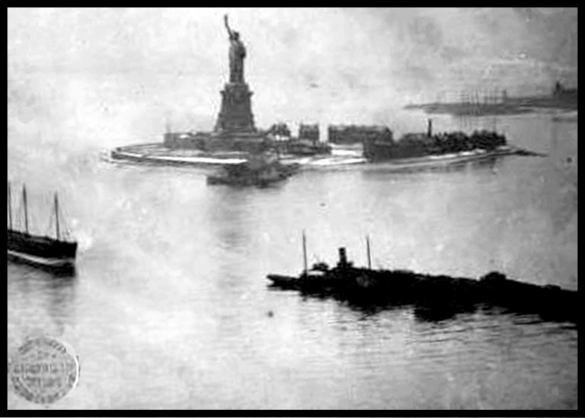

1893

The first three Baháʼís in America were Mr. Thornton Chase, Mrs. Kate Ives and Mr. William H. Hoar of New York City. Mr. William H. Hoar learned about the Faith from Reverend Henry E. Jessup, a missionary who labored for 54 years in Beirut, Syria at the Worldʼs Fair, Worldʼs Parliament of Religions in Chicago. Shoghi Effendi mentions in God Passes By that this was the first public mention of the Faith in the United States. Hoar joined a group to listen to Dr. Ibrahim Kheiralla and became convinced of the truth of Bahá’u’lláh’s mission in 1896.

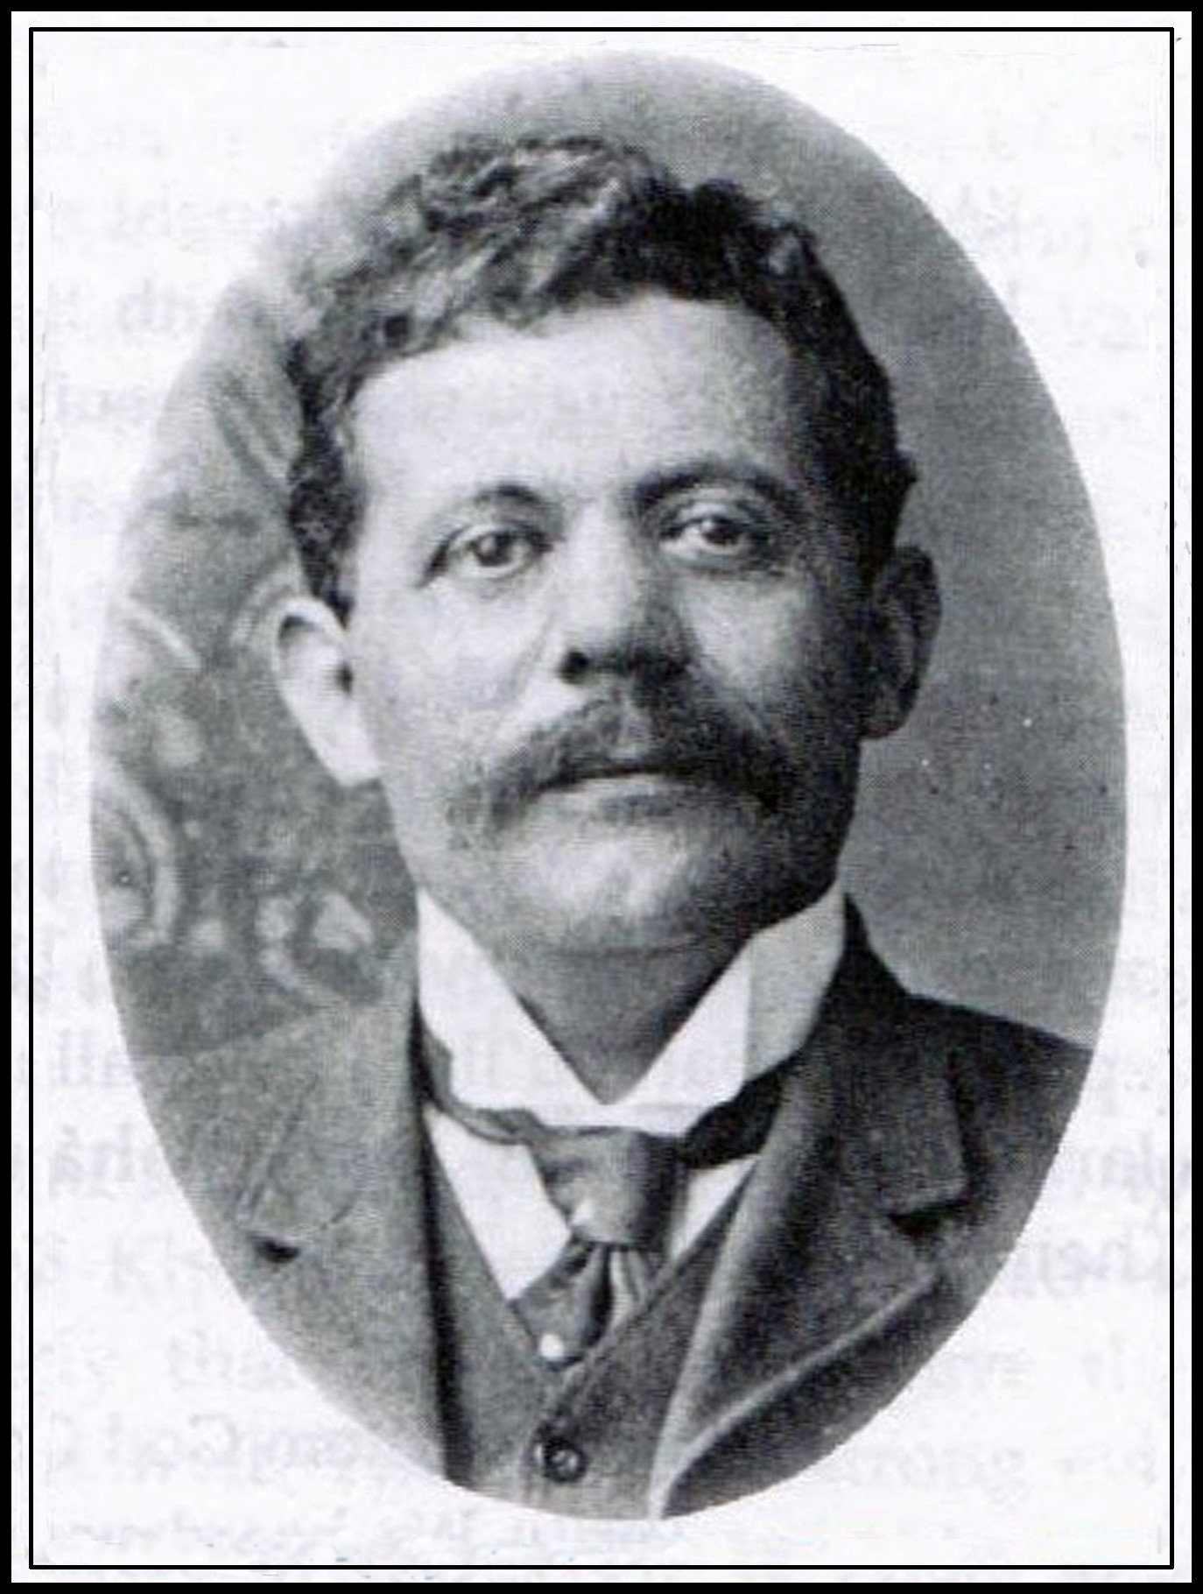
Mr. Anton Haddad was probably one of the first Middle Eastern believers to travel to New York City. He was Dr. Ibrahim Kheiralla’s friend and business partner. Very active in the growth and development of the New York area
Bahá’í communities, his letter to Dr. I. Kheiralla in the winter of 1897-1898 describing his first meeting with the Master in the Holy Land was copied and widely circulated among the friends in NY. An account of his second pilgrimage in the fall of 1899 was published as A Message from Acca.

1895
Mr. Arthur Pillsbury Dodge learned of the Faith from Dr. Sarah Burgess in Chicago, who had heard Dr. Ibrahim Kheiralla speak.

1897
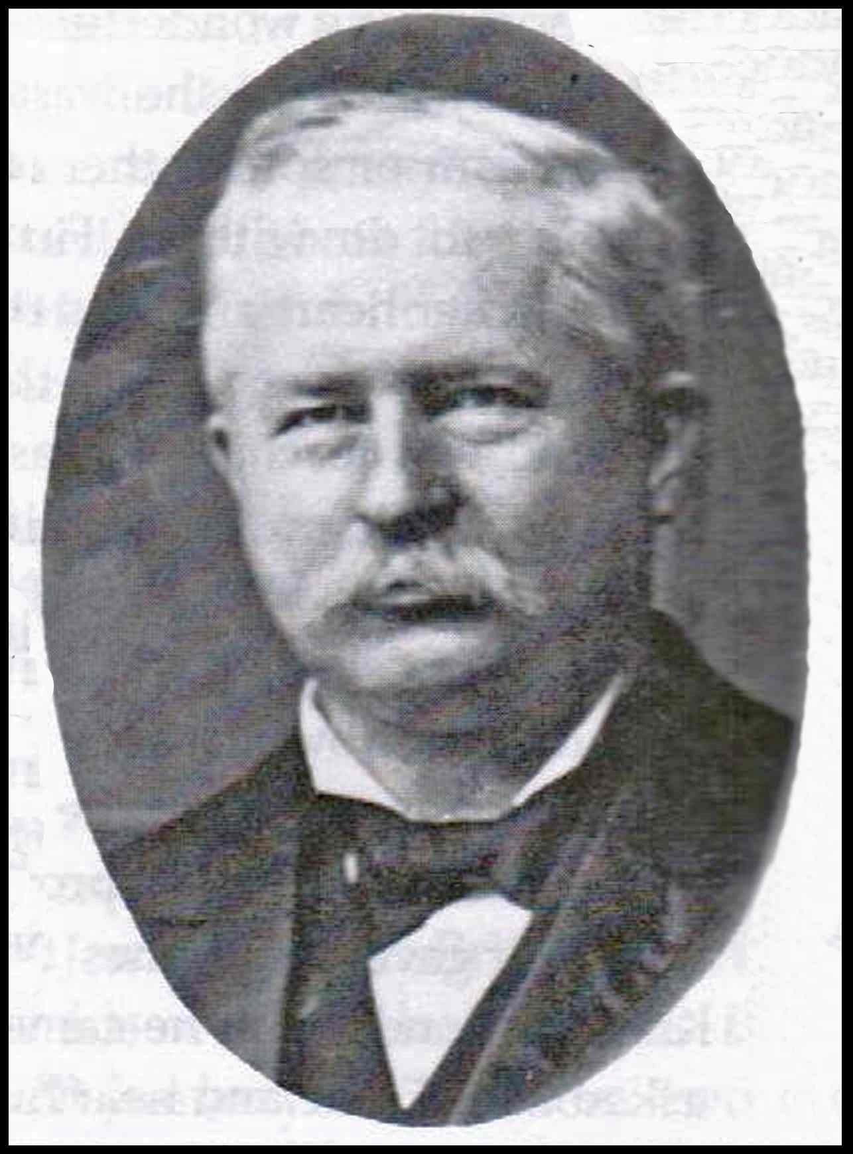
Mr. Arthur Pillsbury Dodge learned more about the Cause just before moving to New York City. He visited Haifa in 1900 and Dr. Edward Granville Browne in Cambridge. A lawyer, publisher and selfmade man, he was named a Disciple of ‘Abdu’l-Bahá by Shoghi Effendi.

1897 Mrs. Lua Getsinger accepted the Faith in Chicago.

1898
Mr. Arthur Pillsbury Dodge held the first Bahá’í classes in his home in NYC and the first public meetings on the Faith with talks given by Dr. Ibrahim Kheiralla. The first person to become a Bahá’í in NYC was Mr. James F. Brittingham, then of Weehawken, NJ, who first heard the Message from his sister, Mrs. Dixon of Chicago. Mrs. Mary H. Tousey organized the classes at Dodge’s home. Later that year, Mr. Howard MacNutt received the Message.

1899
Mr. George Witte of Brooklyn received the Teachings from Mr. Howard MacNutt after first hearing about the Faith from Mr. Braucher of Danville.

Mrs. Ruddiman from Michigan visited Mr. and Mrs. Hooper Harris, who joined Dr. Ibrahim Kheiralla’s class at the home of Mr. Arthur Pillsbury Dodge. Dr. Ibrahim Kheiralla had told Mrs. Ruddiman about the Bahá’í Teachings when he had gone to her home to sell rugs. She took him to Chicago and introduced him to Mr. Thornton Chase.

Mr. Frank Osborne attended classes at the home of Mr. Howard MacNutt and brought 13 others with him. The invitations included Bible references.

Dr. Edward Getsinger organized the Hoboken Assembly and Board, which included Mr. J.F. Brittingham, Mrs. Isabella D. Brittingham, Mr. Arthur James, Mr. Charles T. Jones, and Dr. N.C. Rhodes.

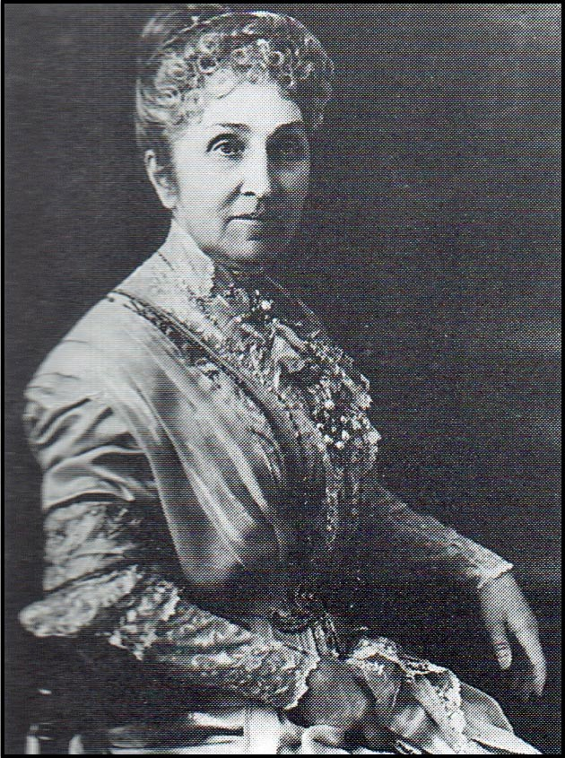
Mrs. Phoebe Hearst of California financed and organized the first pilgrimage of Western believers to Acca in September 1898. She also financed a number of Bahá’í teachers and some publications including the first English translation of the Arabic Hidden Words. The inclusion of Ms. Mary Virginia Thornburgh-Cropper as her companion on pilgrimage later resulted in the beginnings of the Faith in England.

1900

A Tablet from ‘Abdu’l-Bahá to the American believers was presented through ‘Abdu’l-Karim Effendi, who had been the teacher of Dr. Ibrahim Kheiralla.

Mr. Arthur Pillsbury Dodge established meetings in the assembly hall of Stephen Merritt Undertaking Establishment with audiences of about 400. He also rented a studio in Carnegie Hall for meetings in NYC. Mr. Arthur Pillsbury Dodge received the first Tablet ever to an American believer, written in Arabic by ‘Abdu’l-Bahá in His own handwriting and translated by Mr. Anton Haddad. A Tablet to the Hoboken Assembly was received through Mr. J.F. Brittingham. Mr. Arthur James was appointed Chairman of the Hoboken “Board of Council”, a position he held for 25 years.

August 25, 1900 Mr. and Mrs. Arthur Pillsbury Dodge, Mrs. W. H. Hoar and Dr. Edward and Mrs. Lua Getsinger went to Acca and were with ‘Abdu’l-Bahá for 9 days.

September 1900, ‘Abdu’l-Bahá wrote in His own handwriting three Tablets for Mr. Arthur Pillsbury Dodge, explaining “vicarious atonement”, “the Trinity” and the “Immortality of the Soul”. Professor Edward Browne, in London, translated the Tablets.

November 25, 1900 A committee was formed at a meeting held at Madame Pote’s Studio, where the matter of organizing an Executive Board was discussed and 57 Tablets for the American believers from ‘Abdu’l-Bahá were presented.

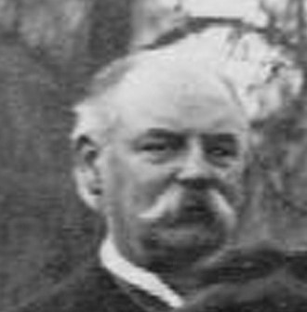
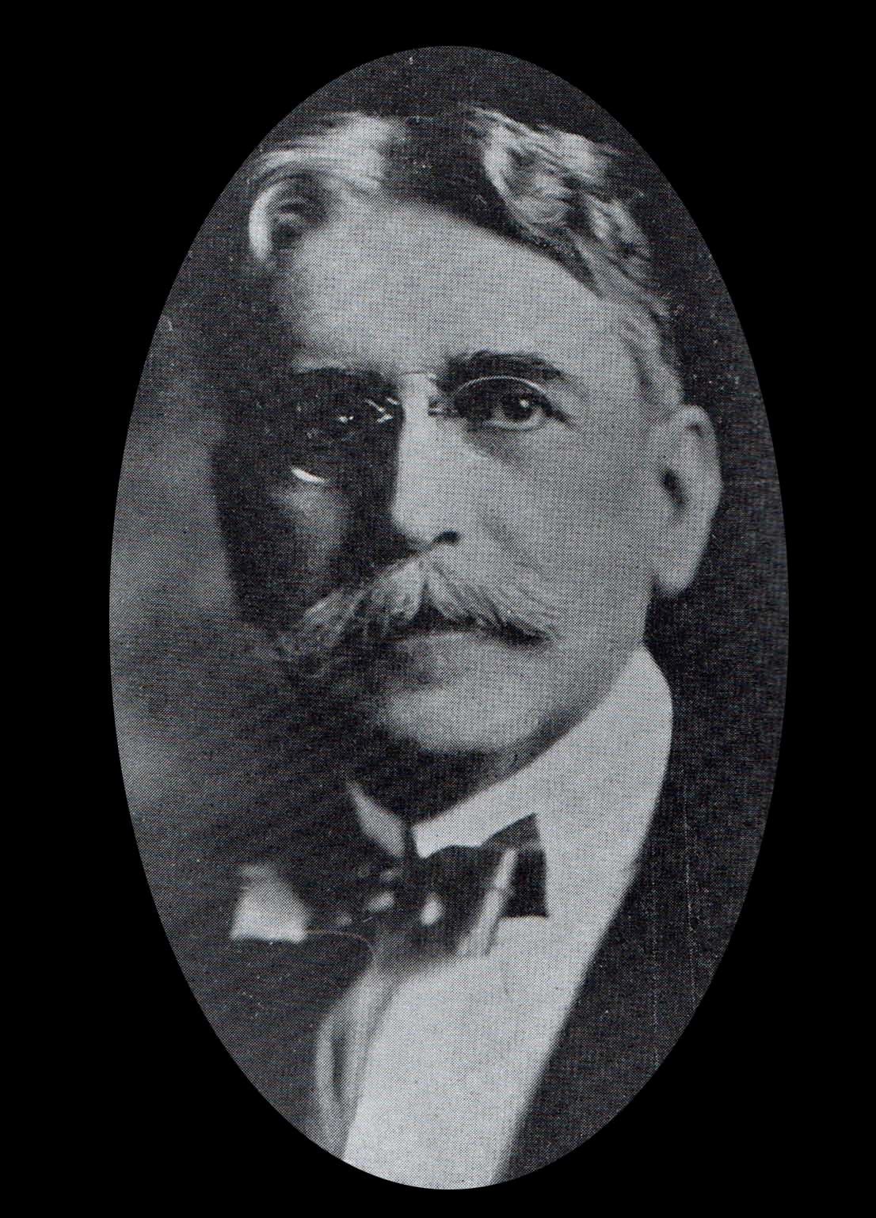
Thornton Chase

‘Abdu’l
-
Bahá called him the first American
believer. He founded what later became the
Bahá’í Publishing Trust.

Mr. William H. Hoar was named
a Disciple of ‘Abdu’l-Bahá by Shoghi Effendi.

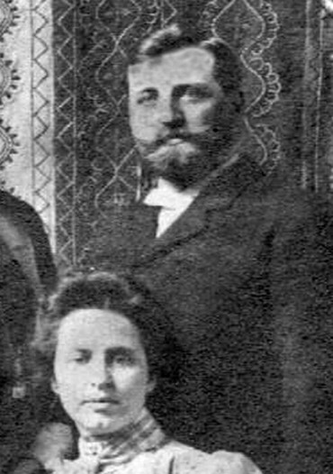
Mrs. Lua Getsinger, and her husband Dr. Edward Getsinger, were very involved in the development of the Faith in New York City. She was given the title “Herald of the Covenant” by ‘Abdu’l-Bahá and was named a Disciple of ‘Abdu’l-Bahá and “Mother Teacher of the West” by Shoghi Effendi. They went on pilgrimage in the fall of 1900 with Mr. and Mrs. Arthur Pillsbury Dodge and Mr. and Mrs. William Hoar.

December 7, 1900 at room 601 of the Carnegie Building, nine men were elected to the first Board of Council of New York.

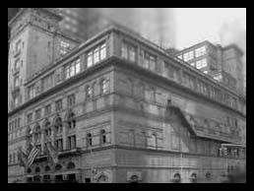
Seated, left to right:
Mr. Clement Woolson, Mr. Howard
MacNutt, Mr. Arthur P. Dodge,
Mr. Charles E. Sprague Standing, left to right:
Mr. Anton F. Haddad (honorary),
Mr. Frank E. Osborne, Mr. Hooper Harris, Mr. William H. Hoar, Mr.
Andrew Hutchinson, Mr. Edwin A.
Putnam

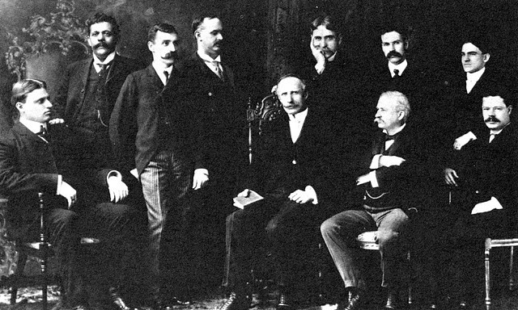

1901

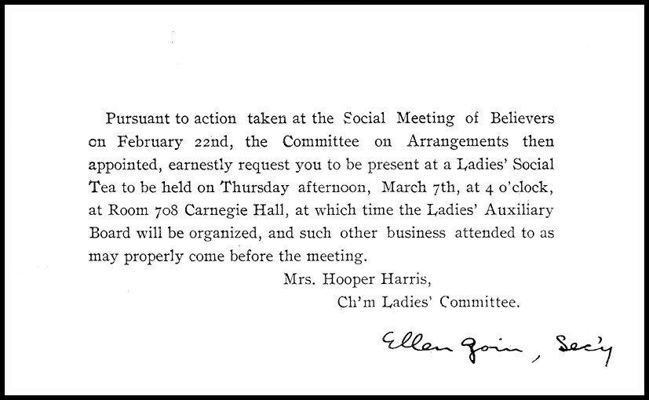

March 7, 1901 a ladies social tea in room 708, Carnegie Hall, was held in order to organize the Ladies’ Auxiliary Board.

July-October, 1901 Mrs. I. D. Brittingham made a pilgrimage to Acca and spent five days with ‘Abdu’l-Bahá.

August 1, 1901 A farewell breakfast was held for a Persian believer, ‘Abdu’lKarim, who had been in New York for two months.

The first Noble Prizes were awarded. President McKinley was shot.

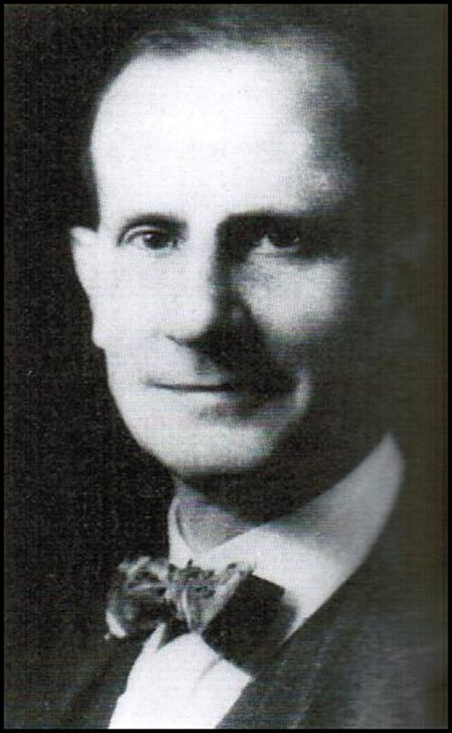
Mr. Roy Wilhelm was posthumously named a
Hand of the Cause of God on December 23, 1951. He became a Bahá’í when he accompanied his mother on her pilgrimage to ‘Akká in 1907. He introduced Martha Root to the Faith in 1908. In 1909 he was elected to the Executive Board of the Bahai Temple Unity and served on the American National Spiritual Assembly. A Unity Feast was held at his home in West Englewood, NJ, in June of 1912, an event commemorated every year.

1902

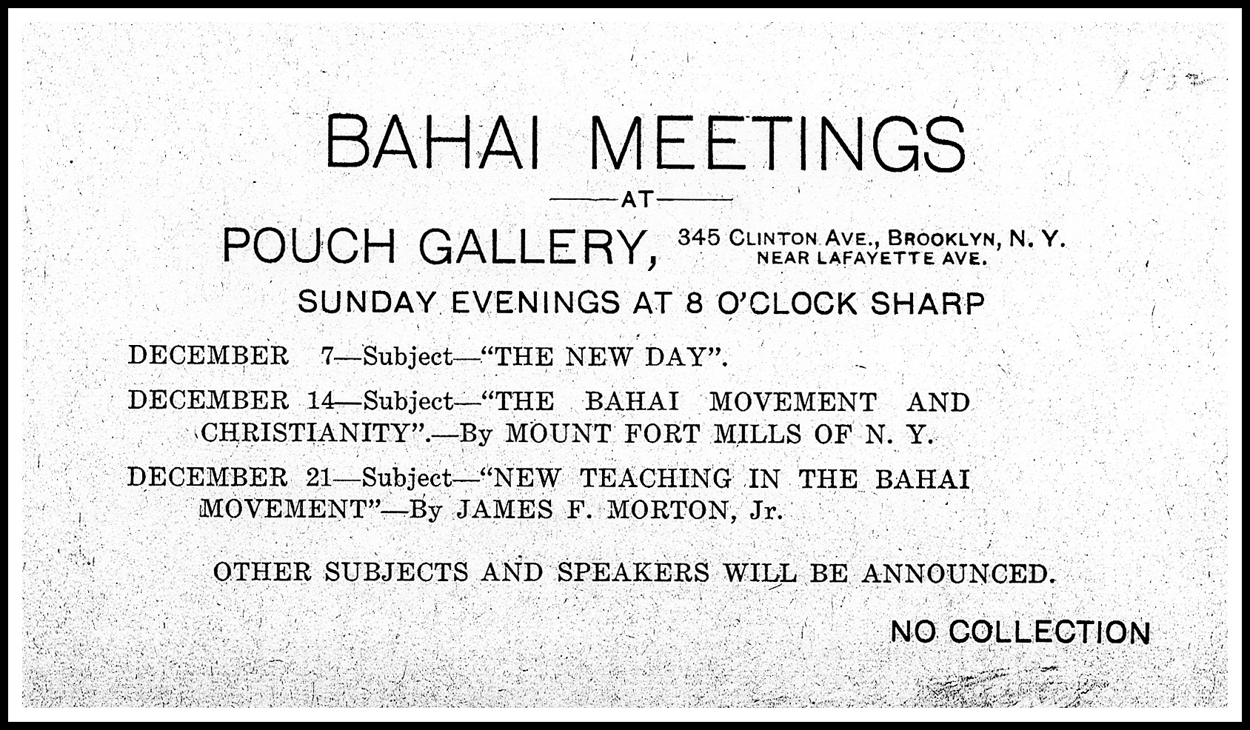

An extract from a Tablet to Mr. Howard MacNutt from ‘Abdu’l-Bahá refers to New York as the “City of the Covenant”.

June 22, 1902 a committee of Americans in Paris asked Mr. Bowen, the U. S. Minister to Persia, to petition the Shah of Iran for protection of the Bahá’ís.

June 1902 Mr. Arthur Pillsbury Dodge asked the friends to contribute to a gift of love and appreciation to Mr. Anton. F. Haddad who had endeared himself to so many.

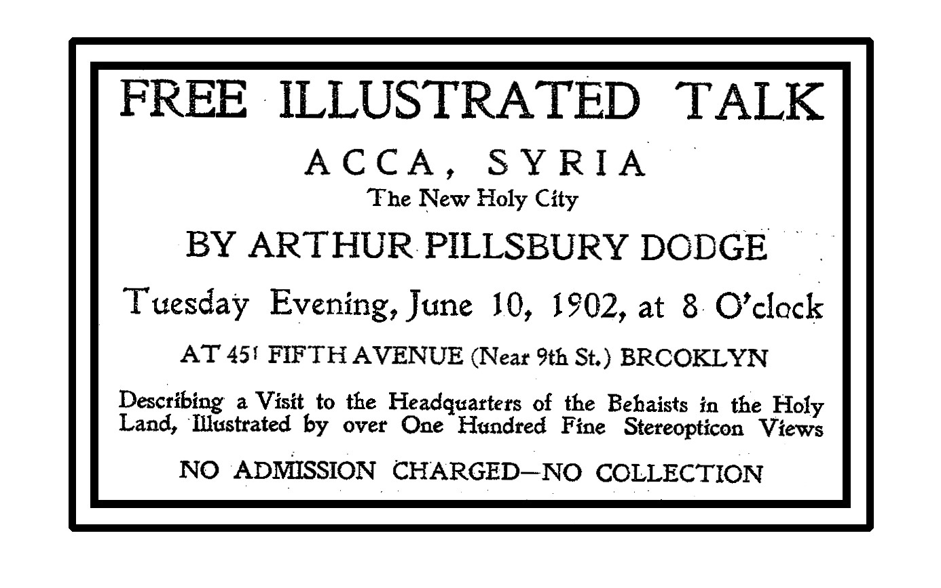
1903

February 19, 1903 a letter to the New York Spiritual Assembly was received from the House of Spirituality in Chicago concerning the Fast.

Mr. Orville Wright and Mr. Wilbur Wright made the first successful flight in North Carolina. Ms. Marie Curie, the first female to be awarded the Nobel Prize, received the prize for her work in physics.

1904

The New York subway opened. President Theodor Roosevelt was elected.

February 1904 The New York Board of Spirituality sent out a notice detailing the contents of five volumes of Tablets of Bahá’u’lláh.

April 15 – June 1904 “Due to conflicting interpretations of the Teachings” a Commission was appointed to “formulate a plan for the development of unanimity in work and effort for spreading the Bahai teachings.” The report gave the “Outlines of the Bahai Teachings” and “Basic Concepts of the Bahai Revelation.”

Three regular weekly meetings were held at the homes of Mr. Arthur Pillsbury Dodge, Mr. Howard MacNutt and Mr. Charles Sprague.

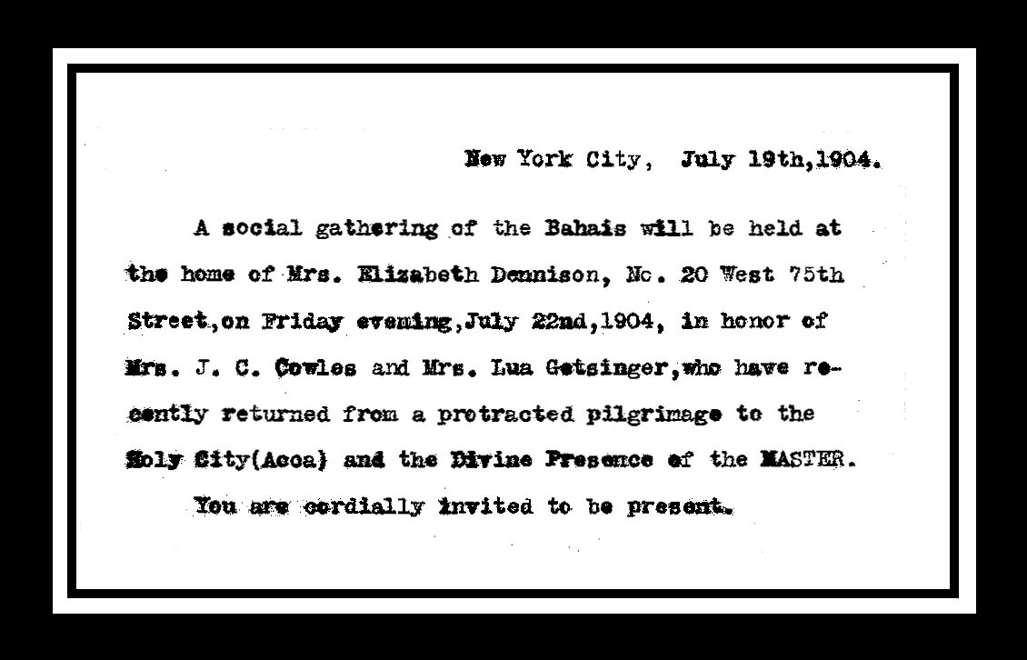
1905

May 19, 1905 in a meeting of NY Board of Council at the home of Mr. Arthur Pillsbury Dodge, Mr. Howard MacNutt described a Nineteen Day Feast he had attended in Acca. The Board then planned the first Nineteen Day Feast to be held the following Tuesday, June 2nd at the home of Mr. Fleming. The Feast was held for several years in different homes.

Thomas Edison invented the electric bulb.

1906

The Great San Francisco earthquake and fire occurred.

March 12, 1906 a Tablet was received from ‘Abdu’l-Bahá to the Spiritual Gathering of New York through Mr. William Hoar, requesting that Mr. Hooper Harris be sent with a companion to India for the purpose of teaching. Mr. Harris sailed to India with Mr. Harlan F. Ober of Massachusetts in November.

‘Abdu’l-Bahá sent a Tablet through Mr. Charles T. Jones to the Board of Council of New York City concerning His Station.

1907

February 1907 in a meeting of the groups from North Hudson, Jersey City, and Newark formed the Bahai Assembly of New Jersey, which later became the “North Hudson and Jersey City Assembly.” This group later sent Mr. Hoar of Fanwood, NJ to the First Mashrak-el-Askar Temple Convention held in Chicago in 1909.

‘Abdu’l-Bahá sent the “Tablet of Purity” to America with Hooper Harris on his return from Haifa and India.

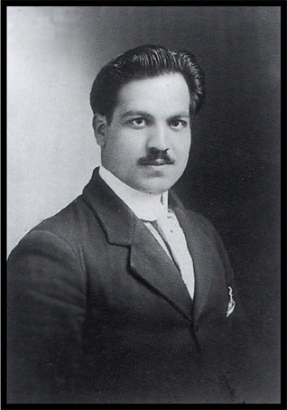
Dr. Zia Bagdadi was a medical doctor from Iraq who came to the United States. He represented Arab Bahá’ís at the laying of the cornerstone of the House of Worship in Wilmette.
In 1907 ‘Abdu’l-Baha asked him to go to Alexandria, Egypt, to establish a hospital for tuberculosis.

1908

August 30, 1908 A Feast of Rejoicing was suggested by Mr. Ahmad Esphahani to celebrate ‘Abdu’l-Bahá being released from prison. The Feast was held at the home of Mr. and Mrs. Howard MacNutt in Brooklyn, just 40 years after Bahá’u’lláh was sent as an exile to Acca, August 31, 1868. Ms. Juliet Thompson held regular meetings that were generally well attended.

Mr. Henry Ford introduced his famous Model-T automobile.

1909
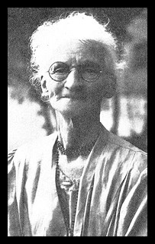

Dr. Susan I. Moody, who became a Bahá’í in 1903, traveled to Iran and started a school for girls.
At the request of ‘Abdu’l-Bahá, she went to Iran to take care of the medical needs of Bahá’í women. She was later joined, at different times throughout the life of the school, by the following believers: Ms. Isabella Brittingham, Dr. Sarah Clock, Ms. Lillian Kappes and Dr. Genevieve Coy.

March 20, 1909 First Bahá’í Temple Unity Convention was held in Chicago. Mr. Mountfort Mills and Mr. William H. Hoar attended.

1909 Martha Root became a Bahá’í.
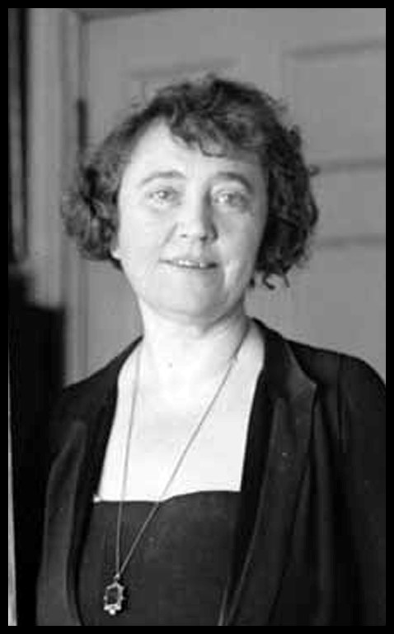
1909 Pilgrimage to Haifa of Juliet Thompson, artist, who had learned about the Faith from Ms. May Bolles in Paris and became a Bahá’í in 1901. She followed ‘Abdu’l-Bahá everywhere when He came to New York in 1912 and was allowed to paint a pastel portrait of Him. Her story of the historical figure Mary Magdalen: I, Mary Magdalen was published in 1940. The
Diary of Juliet Thompson, was published in 1947.
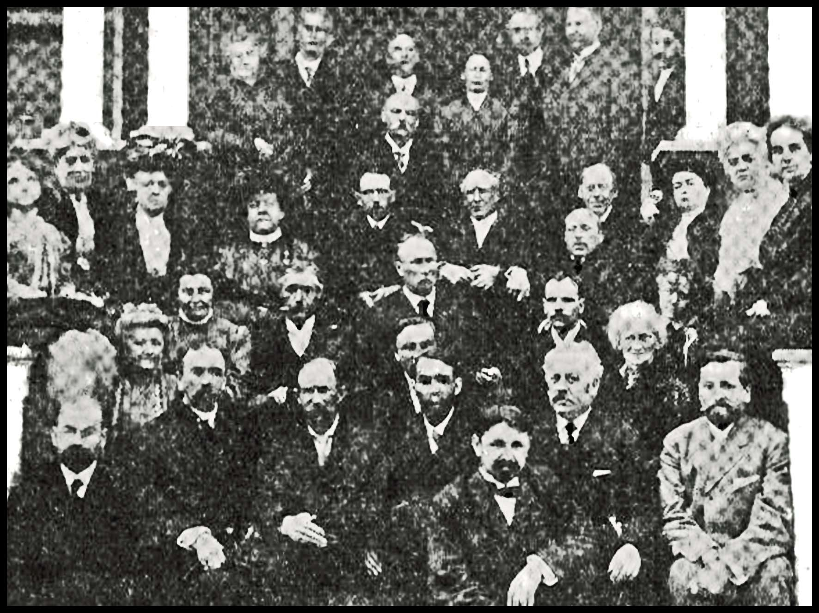

1909

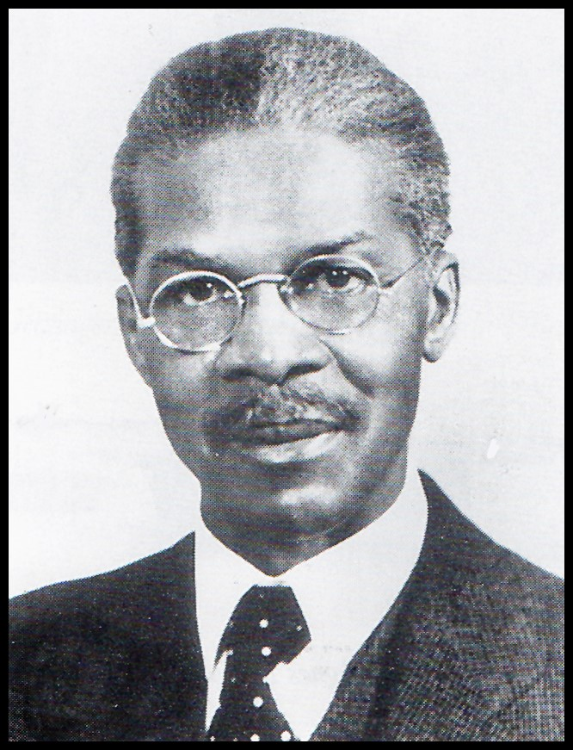
Mr. Louis Gregory, a prominent black lawyer, became a Bahá’í. His marriage to Ms. Loulie A. Mathews, an English Bahá’í, in September of 1912 was the first Bahá’í interracial marriage in North America.
Mr. Gregory was named a Hand of the Cause posthumously. They traveled
and taught the Faith together all over the United States. 1910

January 8, 1910 The Persian American Educational Society was formed to promote education in Persia. The Society cooperated with the Tarbiat School in Tehran. Mr. Sidney Sprague was in charge. Many Americans contributed toward scholarships for children.

1911
Ms. Marie Curie, the first female to be awarded the Nobel Prize received her second Nobel Prize for her work in chemistry.

July 1911 Ms. Lillian Frances Kappes of Union Hill, New Jersey, went to Persia to assist in establishing a school for girls: The Tarbiat School. Ms. Lillian Kappes stayed in Iran until her death and was buried in the terrace surrounding the shrine of the Bahá'í martyrs, Varqa and Ruh'u'llah.

July 27, 1911 Assembly Meeting called at 6 West 90 St. The number of Assembly members were increased from 9 to 27.

1912

April 11, 1912 ‘Abdu’l-Bahá visits America.

The Titanic ship sank. Woodrow Wilson became president in the same year.

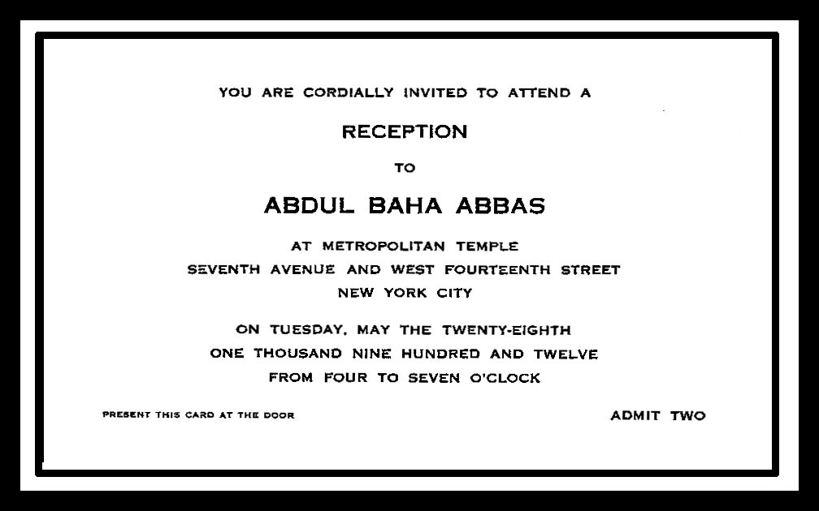
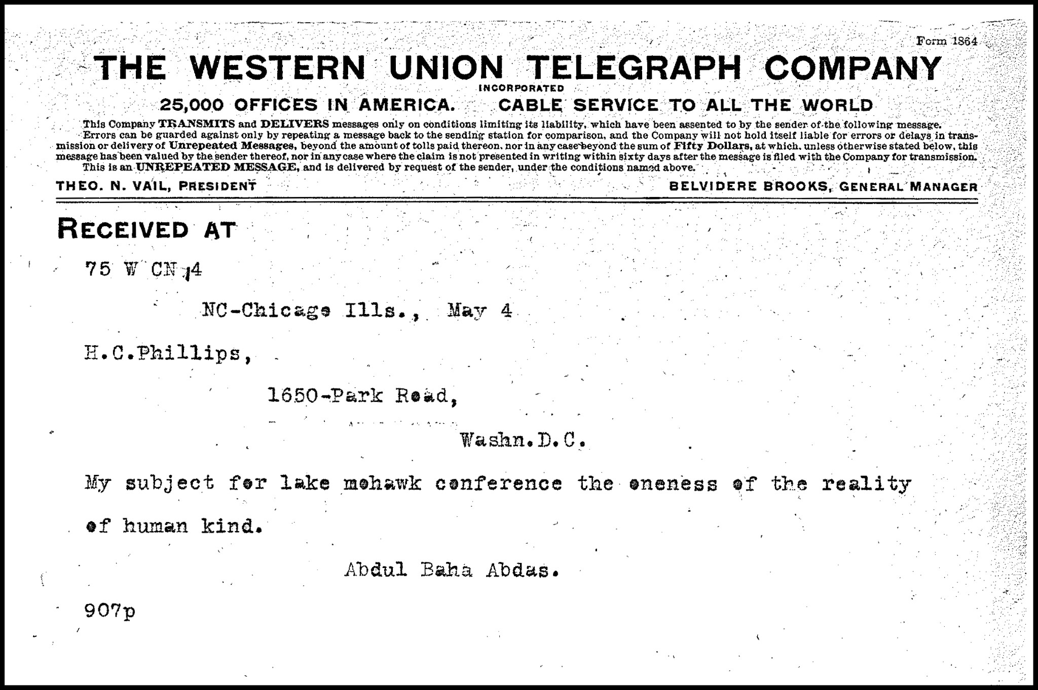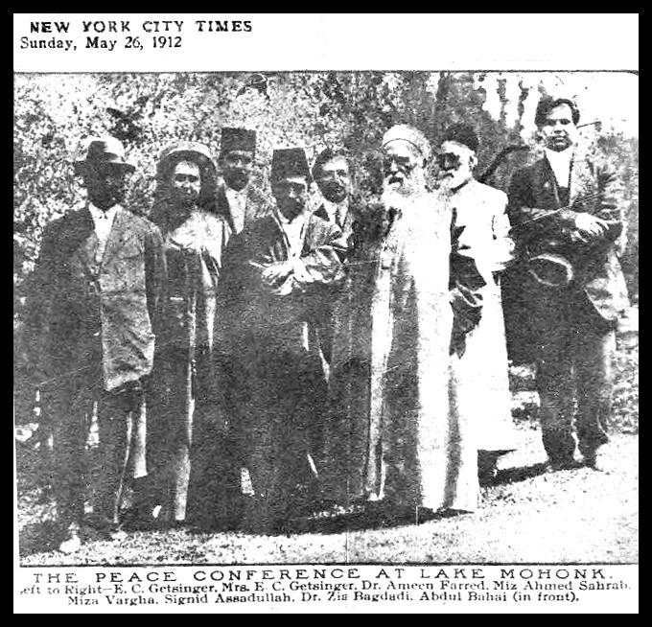

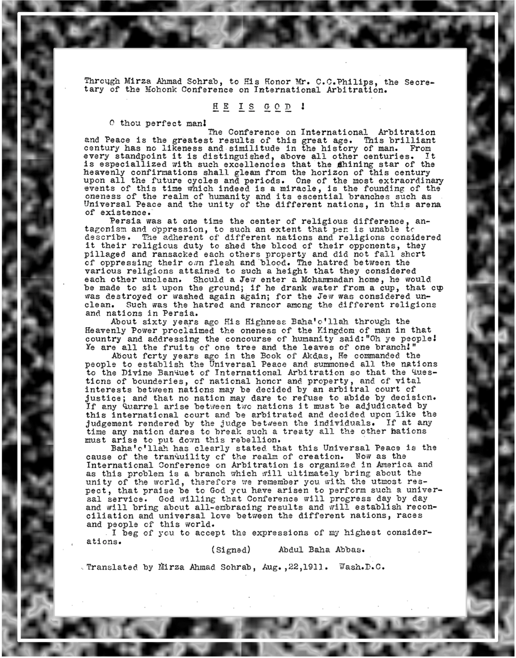

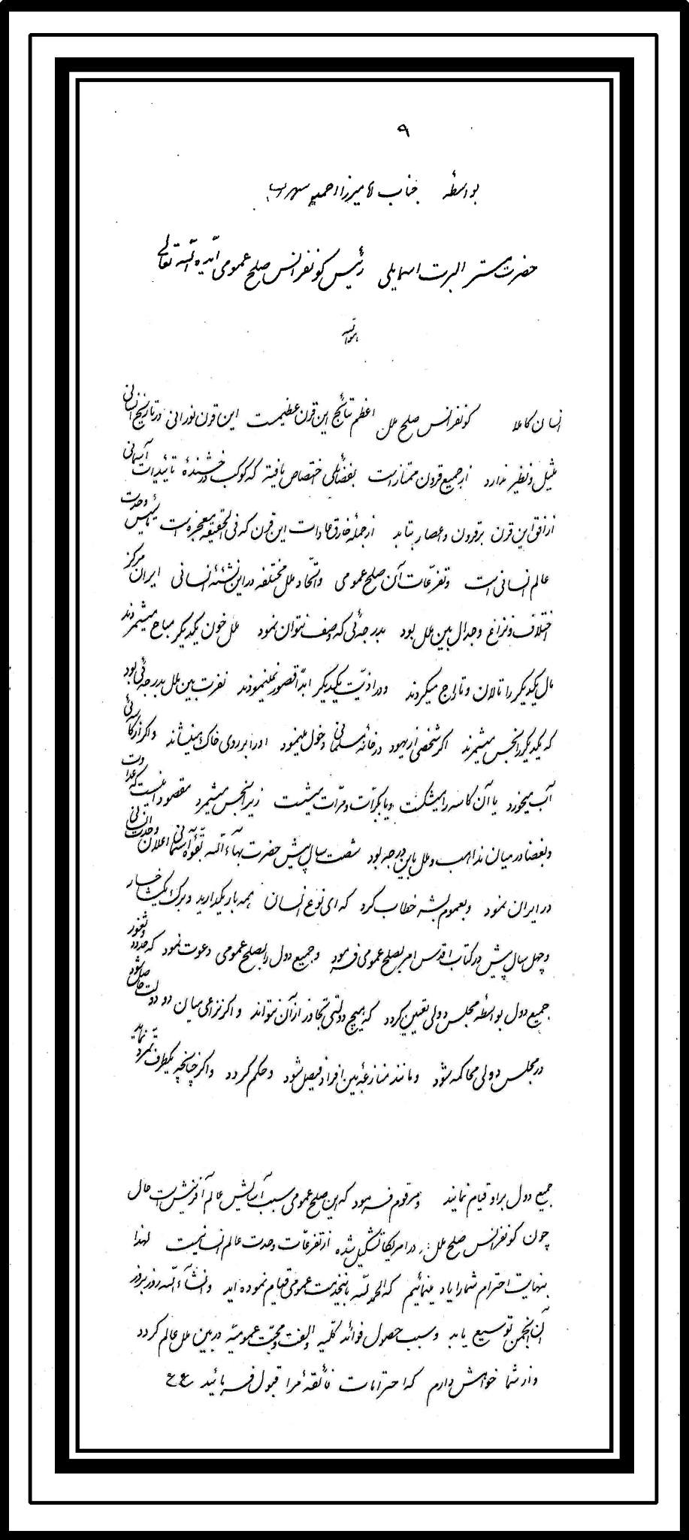
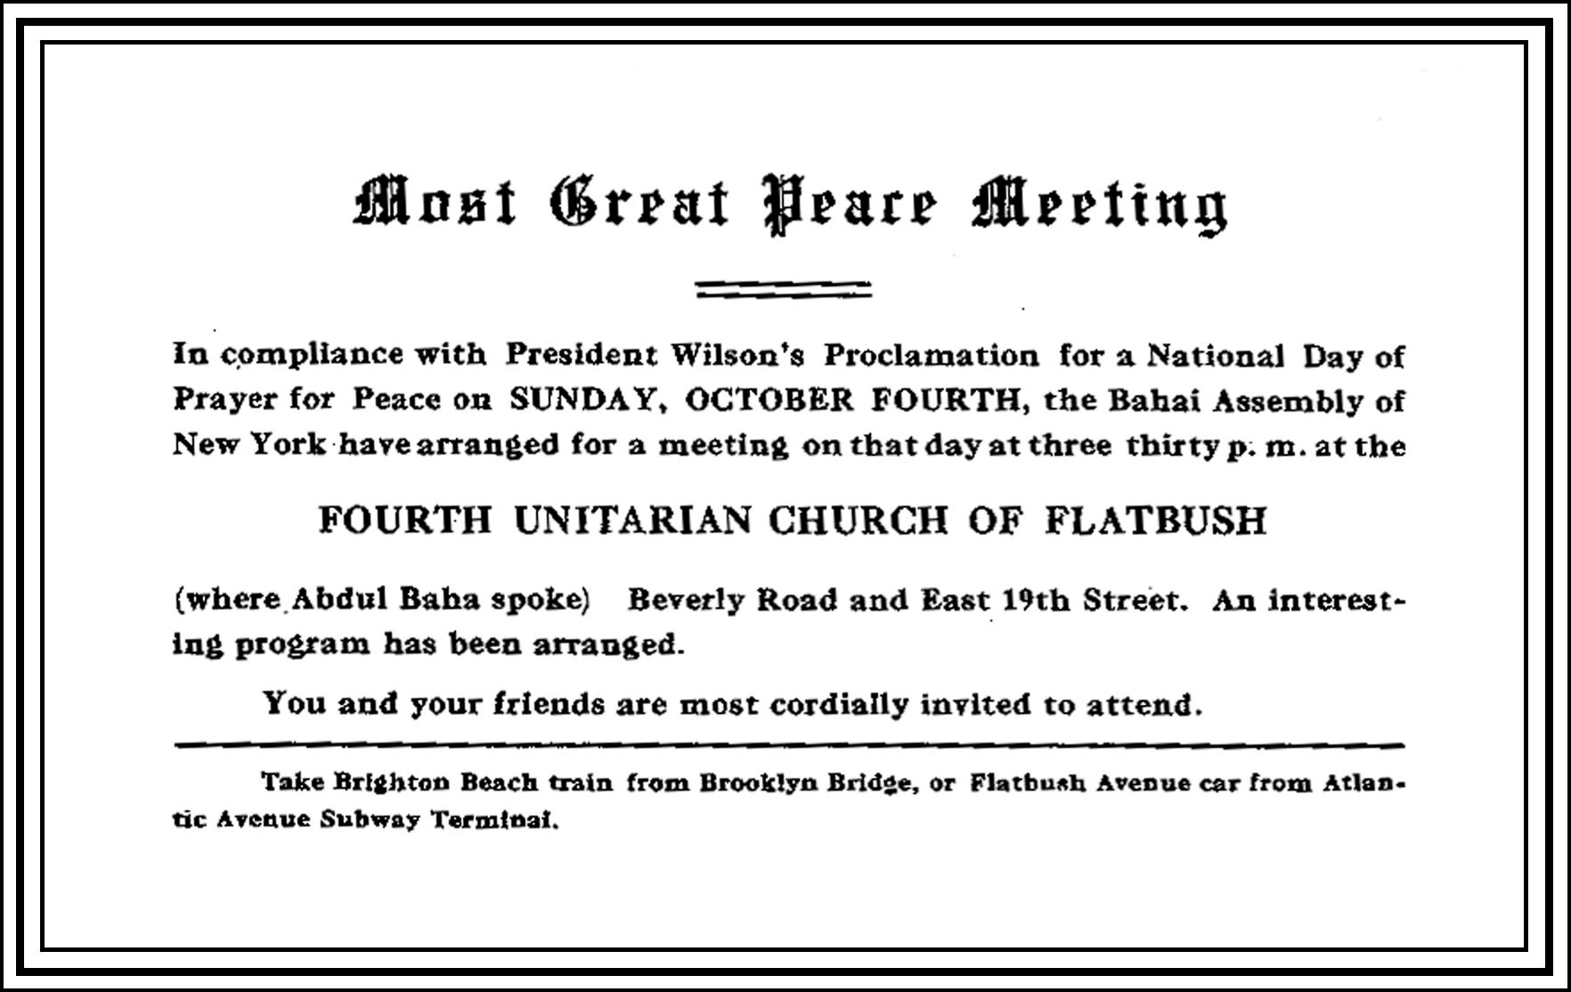
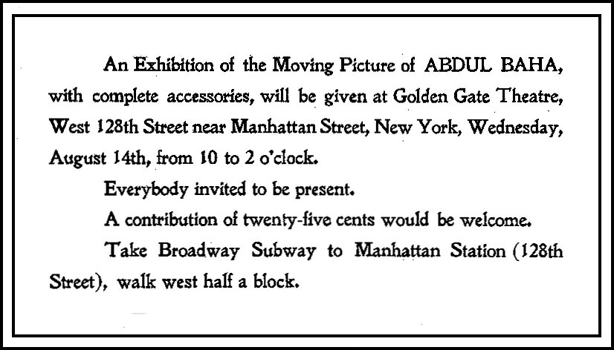
1913

April 26-29, 1913 Public Meetings of the Fifth Annual Convention of the Bahá’í Temple were held in NYC at the home of Dr. and Mrs. Florian Krug. The Feast of Ridván was held at the Columbia University Commons.

1914

The First World War began

1915

April 19, 1915 In commemoration of ‘Abdu’l-Bahá’s gifts to men at the Bowery Mission during His visit in 1912, the friends also gave quarters to each man at the same location.

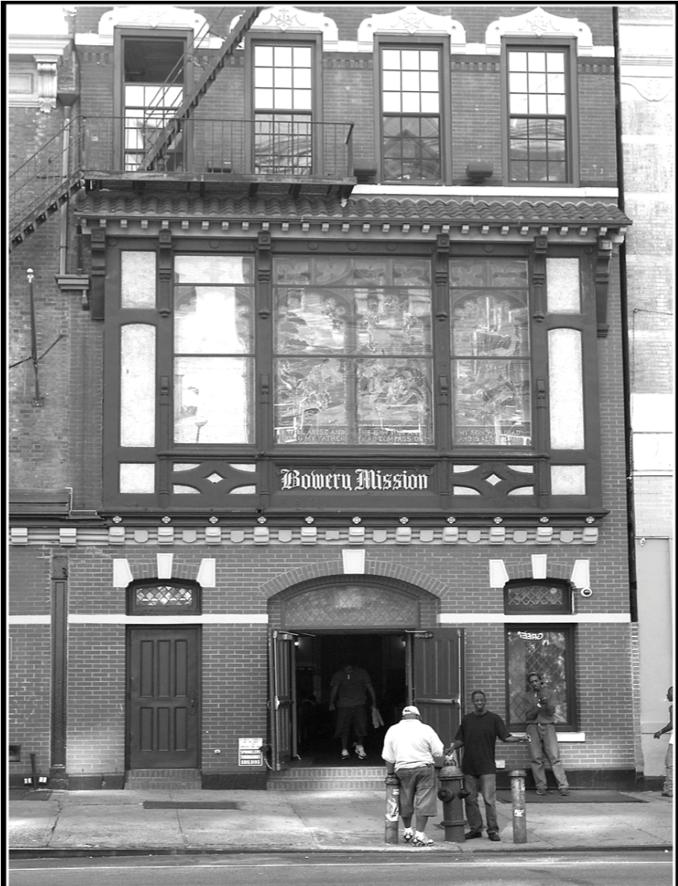

1917

April 30, 1917 Ninth Annual Bahá’í Convention was held in Boston. A Calendar was sent to the Master and returned, corrected by ‘Abdu’l-Bahá, with the words “Now your calendar is correct.”

US declared war on Germany.

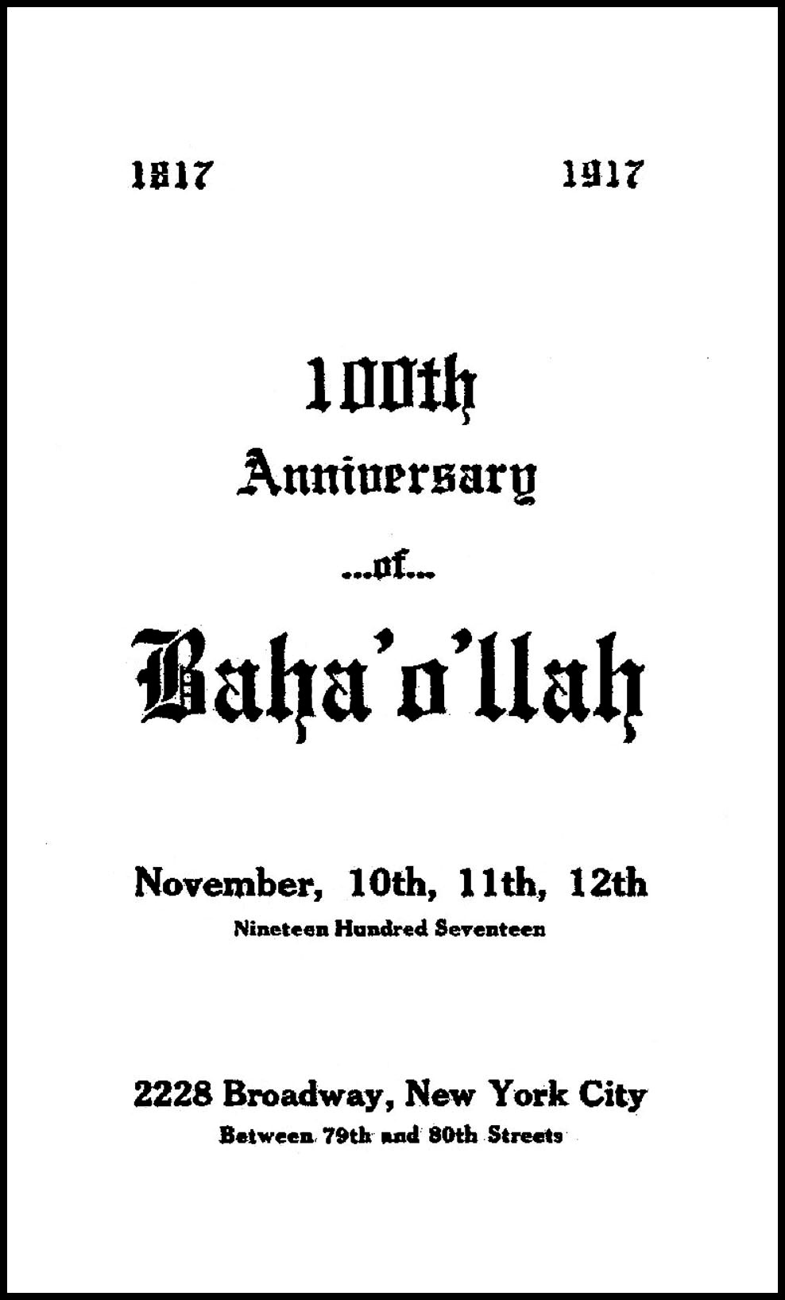

1918
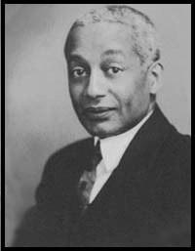
Mr. Alain LeRoy Locke became a Bahá’í in 1918. At that time, it was common to write to `Abdu'l-Bahá to declare one's new faith, and Mr. Locke received a letter, or "Tablet", from `Abdu'l-Bahá in response to his declaration. Locke also enjoyed a close relationship with Shoghi Effendi. He was a leading intellectual of the day and chairman of the Department of Philosophy at Howard University in Washington, D.C. He was a graduate of Harvard, a Rhodes scholar, writer, philosopher educator and patron of the arts who promoted African American writers, artists and musicians. Mr. Locke was considered to be the “Father of the Harlem Renaissance.”

June 11, 1918 Sunday afternoon at 3:30 p.m. Ms. Juliet Thompson gave a talk at the NYC Bahá’í Center on: “The Hidden Words of Bahá’u’lláh”. She was followed by Mr. Howard Colby Ives’ presentation: “The Center of the Covenant of Bahá’u’lláh.” The next evening, June 12, Miss Marie Foote presented “The Station of Women in the Cycle of Bahá’u’lláh.”

1919

April 19, 1919 Delegates from New York City and Brooklyn were sent to the Temple Unity Convention.

April 26, 1919 a presentation of ‘Abdu’l-Bahá’s Divine Plan for the United States was given in New York.

June 19, 1919 the Annual Souvenir Feast of ‘Abdu’l-Bahá’s visit to America at the West Englewood, New Jersey (Teaneck Cabin), was held. The friends were invited to the home of Mr. Louis Bourgeois to see the Temple model designed by him and to hear the story of its inception and materialization.
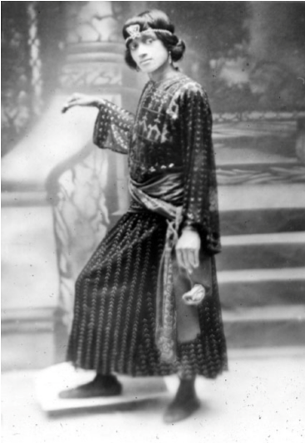
Ms. Dorothy Champ became a Bahá’í in 1919 and went on to become a great teacher of the Faith. She had been a designer, singer, model and dancer. She was so inspired by the Faith that she had given up her career to teach. Ms. Champ was the first black person elected to the Local Spiritual Assembly of the Bahá’ís of New York City.

1920

A model of the Temple was on exhibit at The Kevorkian Gallery, 40 West 57th St, New York City with Ms. Mary Hanford Ford in charge to explain it.

The 19th Amendment passed ensuring women’s voting rights in the United States, and the radio was invented.

1921

June 1921 ‘Abdu’l-Bahá was knighted by the British government.

June 12 and 19, 1921 The “World” magazine published three long articles on the Bahá’í Cause written by Elizabeth Van Patten.

July 9-10 the Fifth Annual Convention of the Bahá’ís of the New York Metropolitan District was held at St. Mark’s Hall, 234 East 11th St., New York.

September 1921 Curtis Kelsey sailed for Haifa to install an electric light plant in the Shrines of Bahá’u’lláh and of the Báb.

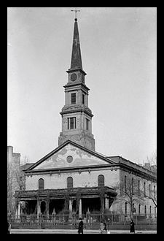
September 22, 1921 a letter to Mr. Mountfort Mills from Dr. Guthrie stated that the Bahá’ís might use St. Marks Church whenever they wished.

November 29, 1921 a cable from Greatest Holy Leaf read: “HIS HOLINESS 'ABDU'L-BAHA ASCENDED TO ABHA KINGDOM”

December 1, 1921 the Press announced the passing of ‘Abdu’l-Bahá.

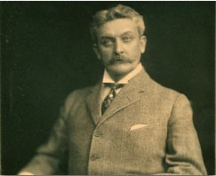
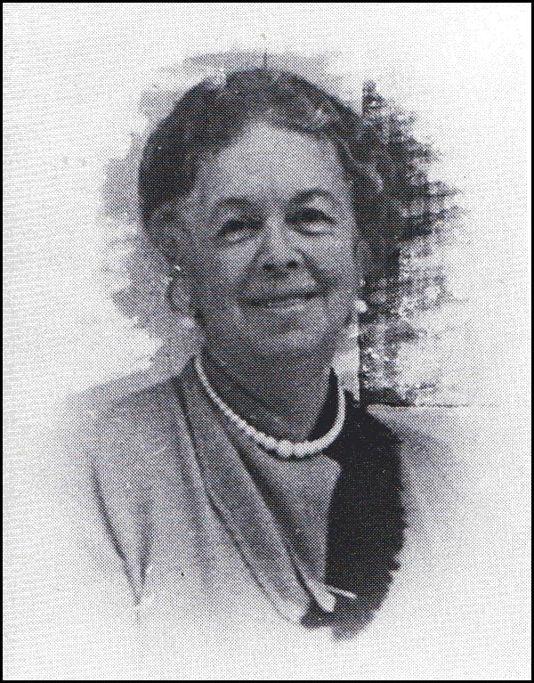
Mrs. Grace Krug was in Haifa with her husband, Dr. Florian Krug, a prominent New York physician, when ‘Abdu’l-Bahá died.

1922

January 17, 1922 a cable from the Greatest Holy Leaf read: “IN WILL SHOGHI EFFENDI APPOINTED GUARDIAN OF CAUSE AND HEAD OF HOUSE OF JUSTICE. INFORM AMERICAN FRIENDS.”

February 7, 1922 Mr. Mountfort Mills and Mr. Roy C. Wilhelm sailed for Haifa for a conference with Shoghi Effendi in answer to his cablegram. They left Haifa on March 20, 1922. February 26, 1922 a meeting was held in New York to consider the Will which reached there on the 25th addressed to Mr. Roy C. Wilhelm who handed the Will to two members of the Unity Board because of a cable: “INFORM ASSEMBLIES WILL PRIVATE.”

March 4, 1922 Shoghi Effendi cabled for a list of all believers in the United States and Canada over 21 years of age.

April 20, 1922 a letter from Haifa, signed by Rouhangese, stated that Shoghi Effendi left the Holy Land for rest and a period of prayer.

May 19, 1922 Dr. Genevieve L. Coy left for Haifa and Tehran to help with the Tarbiat School for Girls.

June 6, 1922 the NY Spiritual Assembly sent a letter to the Greatest Holy Leaf after Shoghi Effendi appointed her in charge of affairs.

August 15, 1922 Mr. Horace Holley was authorized and empowered to secure registration of the title “The Bahá’í Magazine” formerly “The Star of the West” for whatever purpose & whatever time our NSA might choose to use it.

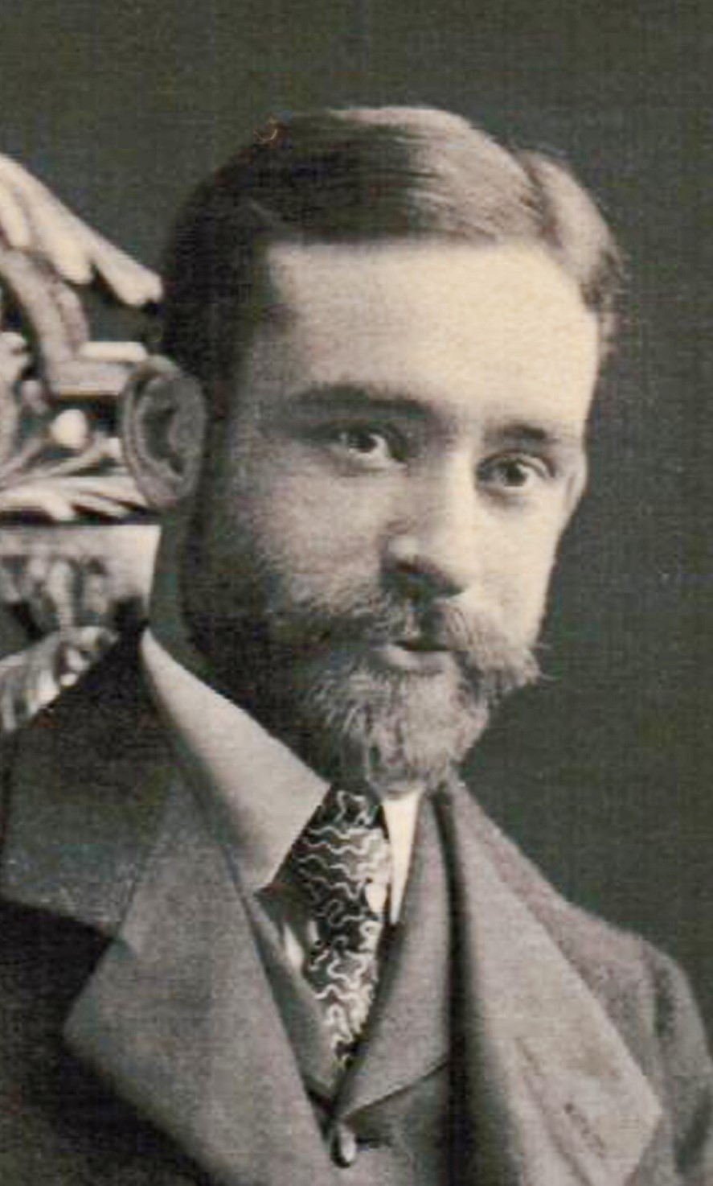
Mr. Mountfort Mills was an eminent lawyer who became a Bahá'í in 1906. He was the first chairman of the National Spiritual Assembly of the United States and Canada and prepared the final draft of the Declaration of the Trust and ByLaws of the National Spiritual Assembly in 1927. He traveled to Haifa to meet the Guardian in 1922 with Mr. Roy C. Wilhelm.

1923

February 22, 1923 Mr. Janabi Fadil, along with his wife and son, returned to America again in time to attend the Convention to be held in Chicago.

April 1, 1923 Mrs. Isabella Chamberlain spoke at a colored church in New Rochelle, New York, and the Pastor announced his willingness to make the church the center of the Bahá’í Movement in that city.

April 1923 by instruction from Shoghi Effendi, 95 delegates were to be sent in total to the Annual Convention. This announcement increased New York’s quota to 10. Since his word came too late to make arrangements for 1923, consequently, only two delegates were elected that year. The letter also required the Local Assemblies to hold annual elections of the Local Spiritual Assemblies. The results were to be announced on April 21st of each year.

April 9, 1923 it was decided to recommend to the Bahá’í Community that one Spiritual Assembly for Greater New York (five Boroughs) be elected, including the friends nearby where there was no Assembly.

April 21, 1923 The New York Spiritual Assembly was elected and the results were cabled to Shoghi Effendi: Mr. Mountfort Mills, Chairman; Mr. Hooper Harris; Mr. Roy C. Wilhelm, Treasurer; Mr. Curtis Kelsey; Mr. Horace Holley, Corresponding Secretary; Ms. Edith Inglis; Ms. Bertha Herklotz, Recording Secretary; Mr. Edward B. Kinney; Ms. Nellie H. Lloyd; and, Ms. Loulie A. Matthews, Financial Secretary.

July 1923 Notice was given to the Community that a “Bahá’í Fund” was established according to the request of Shoghi Effendi. The Treasurer was Mr. Roy. C. Wilhelm.

1924

March 28, 29, and 30 a public conference devoted to Inter-racial Harmony and Peace was held at the public auditorium of the Community Church of NY on Park Avenue at 34th Street and at the Meeting House of the Society for Ethical Culture at 2 West 64th Street. Presenters included Mr. Mountfort Mills, Mr. Franz Boas, Dr. Loro, Taracknath Das, Mr. Stephen S. Wise, Dr. Alain Locke, Mr. James Weldon Johnson, Ms. Ruth Morgan and Mr. John Finley.

1925

February 1925 the Bahá’í community of New York City contributed $530, in response to a request from Shoghi Effendi, for relief of friends in the Persian city of Nayriz, who were suffering from a natural disaster caused by a flood.

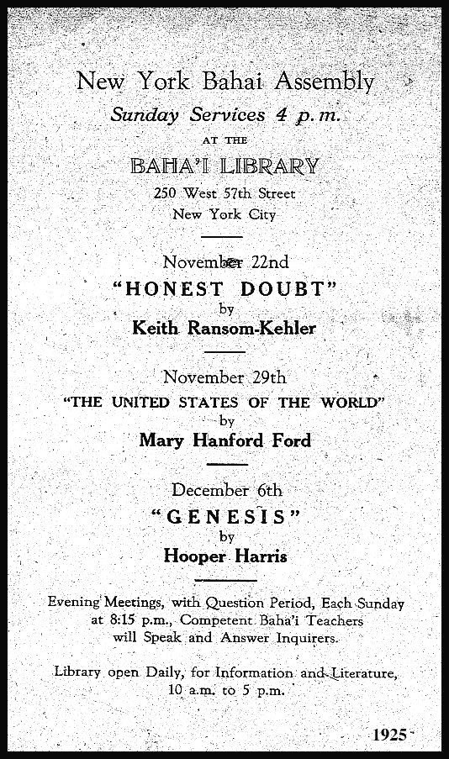
1926

June 26, 1926 Mr. Ali Kuli Khan was invited to represent the Bahá’í Faith at the 13th Annual Congress of the International New Thought Alliance, Parliament of Religions, held at the Hotel Commodore in New York City. He was privileged to deliver the Message to many thousands who were gathered there.

The following events took place at 4 p.m., Sunday afternoons at the New York City Bahá’í Center:

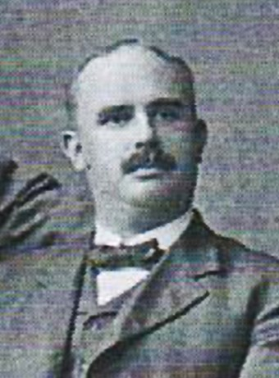
Presented by Mr. Hooper Harris:

July 4 “Signs of the Times”
July 11 “The Great Message”
July 18 “The Victorious World and True Miracle”
July 25 “The Prophetic Proofs”

August 1, 1926 | Ms. Keith Ransom-Kehler presented a talk titled “ Hard Atoms and Soft Souls.”
August 8, 1926 | Mr. R. C. Wilhelm spoke on “ World Amalgamation.”
August 15, 1926 | Mr. Louis C. Gregory lectured on the “ Future of Education.”
August 22, 1926 | Ms. Keith Ransom-Kehler gave a talk on the “ Conquest of Prejudice.”
August 15, 1926 | Mr. Louis C. Gregory posed the question “If a Man Dies, Does He Still Live?”

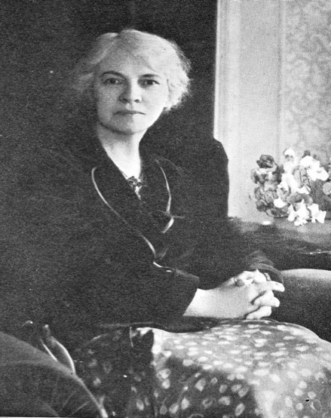
Ms. Keith Ransom-Kehler was named a Hand of the Cause of God posthumously. She contributed to the growth of the New York Bahá’í Community and gave many talks on the Faith.

1926

August 6, 1926 The Shah of Iran was asked to “stay the slaying of Bahá’ís.” The Press notice of the appeal to the Shah to protect Bahá’ís from persecution was published August 9th.

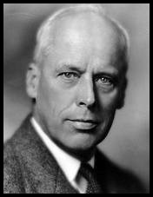
1927 February 6, 1927 After a talk by Mr. Horace Holley on the question “Has Religion Failed?” a forum was held at the New York City Bahá’í Center chaired by Mr. Holley on the topic of “Economics and World Peace.” The distinguished author, Mr. Norman M. Thomas, was the keynote speaker. Mr. Thomas, an alumnus of Princeton University, was a former Presbyterian minister, turned American Socialist and pacifist, who frequently spoke on the differences between socialism and communism. A high school in Manhattan and a library at Princeton University were later named after him.

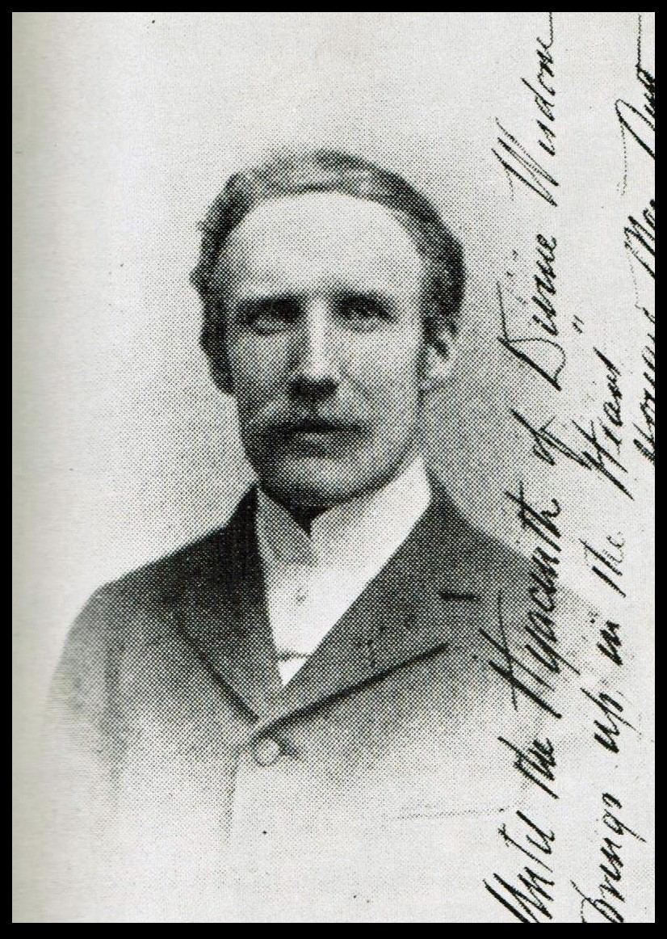
February 7, 1927 a memorial service in honor of Mr. and Mrs. Howard MacNutt was held during the Nineteen Day Feast. A lawyer and business executive, Mr. MacNutt and his wife, Mary, had become Bahá’ís in NY after learning of the Faith from Dr. I. Kheiralla in 1898. In 1902 they moved to Brooklyn where their home became a center of activities for the Faith and where a film of ‘Abdu’l-Bahá was made in 1912. He published a collection of the Master’s talks given in America titled The Promulgation of Universal Peace.

July 7, 1927 Mr. Mountfort Mills received a cable from Shoghi Effendi through the Greatest Holy Leaf suggesting the American Assemblies send cables to His Excellence the High Commissioner in Baghdad, Iraq, urging that the houses (belonging to the Bahá’ís) be restored to their rightful owners.

The National Spiritual Assembly of the Baha’is of the United States and Canada is incorporated. Its charter document, the Declaration of Trust and Bylaws, subsequently serves as the model for the formation of more than 180 National Spiritual Assemblies throughout the world.

1929

November 1929 Motion pictures and lantern-slides were shown and a special
Communication from Shoghi Effendi was read.

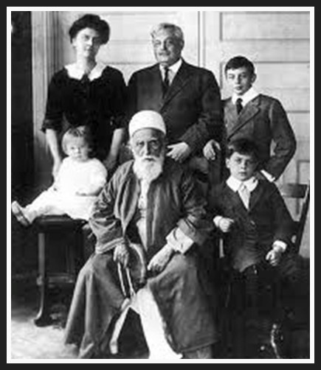
Mr. Edward B. (Saffa, or Serenity) Kinney and his wife, Carrie (Vaffa, or Certitude). When the Master came to New York City the first private home where He gave a talk was at the Kinney’s. Their West End home l was often a meeting place for the Bahá’ís. A wealthy New York City musician, he was introduced to the Faith in 1895. In 1907 the Kinney’s went to Alexandria, Egypt to help Dr. Zia Bagdadi establish a hospital for tuberculosis at the request of the Master.
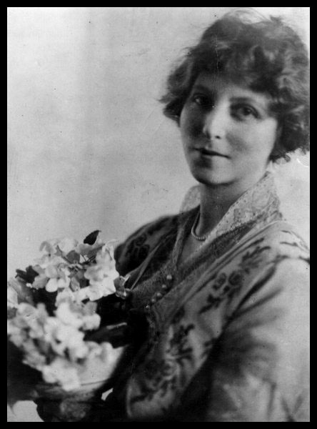
Mrs. May Ellis Bolles Maxwell, wife of Mr. Sutherland Maxwell. She learned of the Faith in
Paris and joined the group of Bahá’ís traveling with Mrs. Phoebe Hearst on pilgrimage in 1899. Her daughter, Mary, married the Guardian in 1937.

March 31, 1929 she gave a talk at the NYC Bahá’í Center on “Divine Administration”. She traveled extensively for the Faith and was declared a martyr by the Guardian when she passed away in Buenos Aires, Argentina, in 1940.
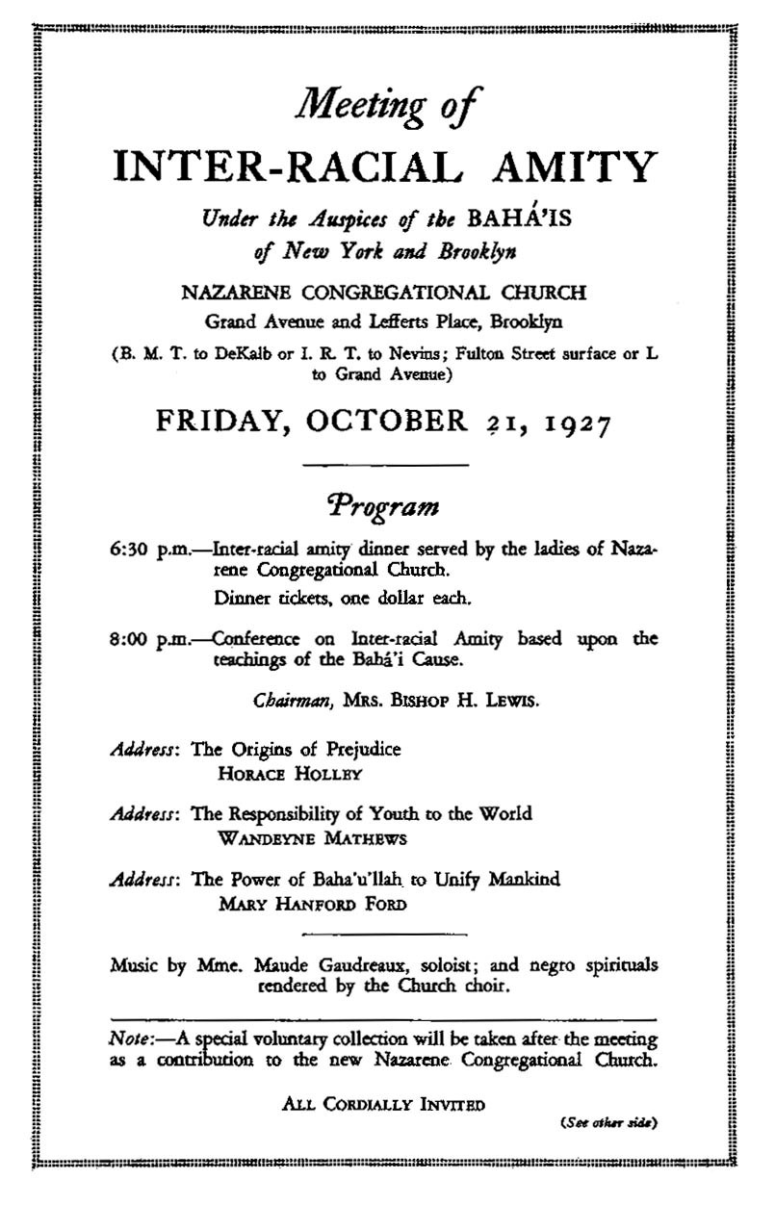

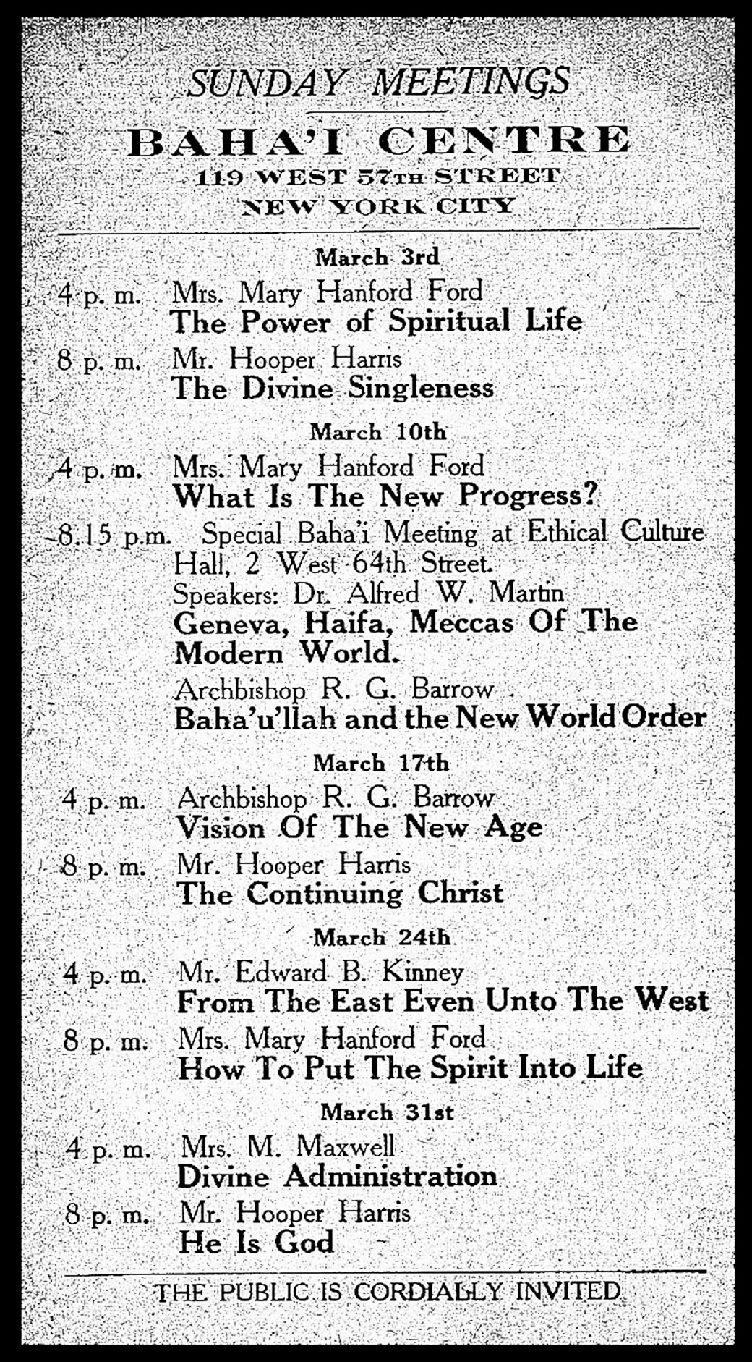

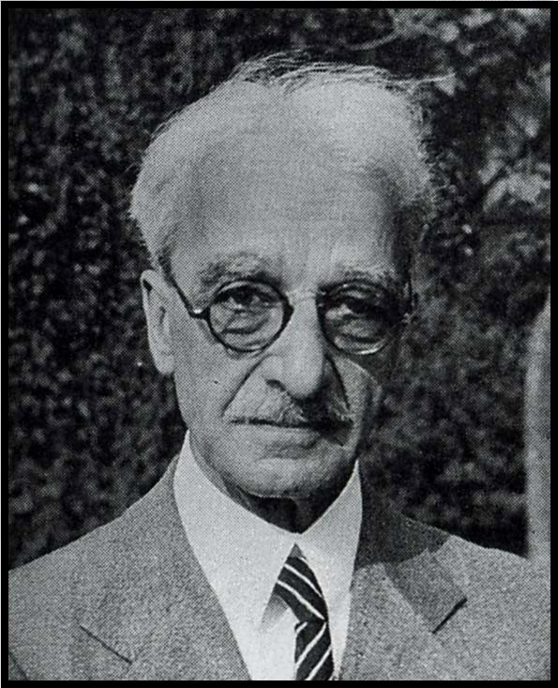
Howard Colby Ives had been a Unitarian minister from New Jersey who had heard of the Bahá'í Faith at a time of deep spiritual searching. Mr. Ives memoir Portals to Freedom was first published before many of the current translations of Bahá’í Writings were available, and provided a personal account of his meetings with ‘Abdu’l-Bahá. He loved the Master very much and looked at meeting Him as the dividing point of his life.

January 19, 1930 a Special Sunday Program: Mr. Alfred Lunt of Boston, member of the National Spiritual Assembly, presented a program: “The Bahá’í Teachings: Basis of New Direct Methods.”

December 18 Mr. Alain L. Locke Ph.D., Professor of Philosophy, Howard University, Washington, D.C., presented “Toward a Universal Culture”.

January 22 1930 Dr. Alfred W. Martin of the Ethical Culture Society presented
“How to Cultivate Internationalism”

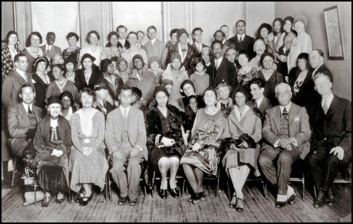

Race Amity conference, New York, New York 1930

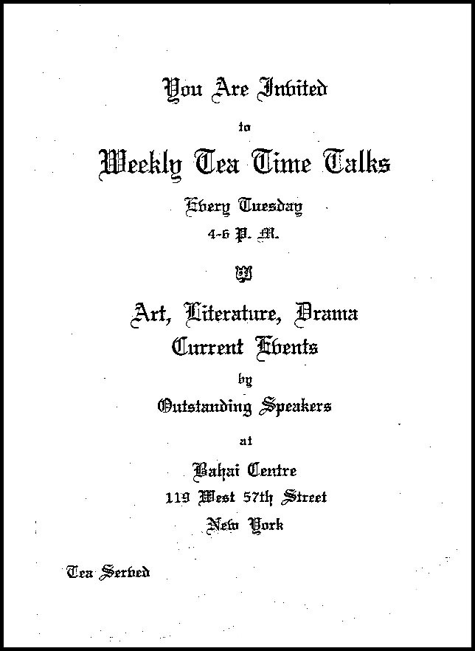

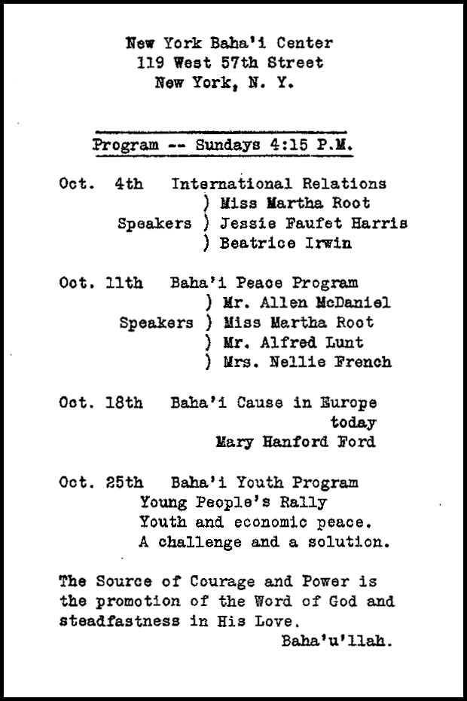

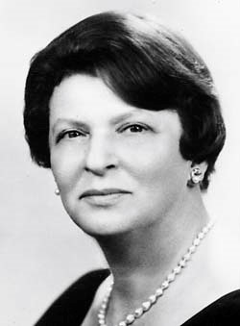
Mrs. Mildred Mottahedeh was the first Bahá’í
International Community representative to the United Nations from 1948-1967. She was a successful businesswoman, contributor to the arts and a promoter of humanitarian works. She founded, with her husband, Mottahedeh and Company, a world-renowned importer of porcelain. They were supporters of socioeconomic development and established a foundation to support projects around the world. She was instrumental in providing support for the New Era High School and New Era Development Company in India.

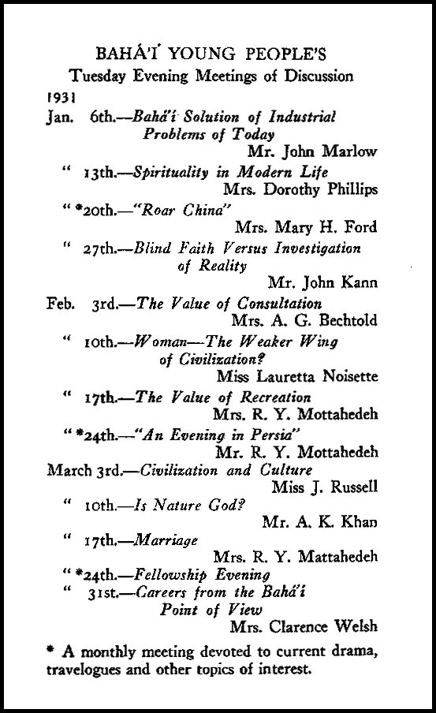

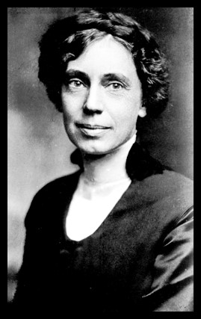
October 1931 Ms. Martha Root gave many addresses in New York. She addressed the Esperantists of New York City on October 3rd in the Hotel Endicott, followed by an address at the International House at Columbia University. October 4th at the Bahá’í Center she gave a talk on “
My World Travels in the Interest of Universal Peace.” October 7th at NY University she discussed “Youth’s Place in the New World Order.” October 8th: Before the Real Estate Society she spoke on “What can you do for Universal Peace?” October 9th at Hunter College she lectured 25,000 students on the same subject. On the 11th she gave a talk at the NYC Bahá’í Center “Cultural Assets of our Races.” This brief recap of a few days was typical of her schedule.

1932

Sunday Teas were held at the New York Bahá’í Center from 4-6 pm. These Teas were in addition to additional talks presented during the month by such speakers as Mr. Horace Holley, Dr. Genevieve Coy, Ms. Mary Hanford Ford, Ms. Loulie Mathews, Mr. Eliot White, and Kahla Khandensala.

January 12th Dr. W. Burkhart Dubois gave a talk on “The New South” and January 26th the artist Sigismund Ivanowski presented “Art of the New Day.”
His portrait of ‘Abdu’l-Bahá was on exhibit at The Art Center, 55 East 56th Street, during the first two weeks of January. All meetings were free and no collections were made.

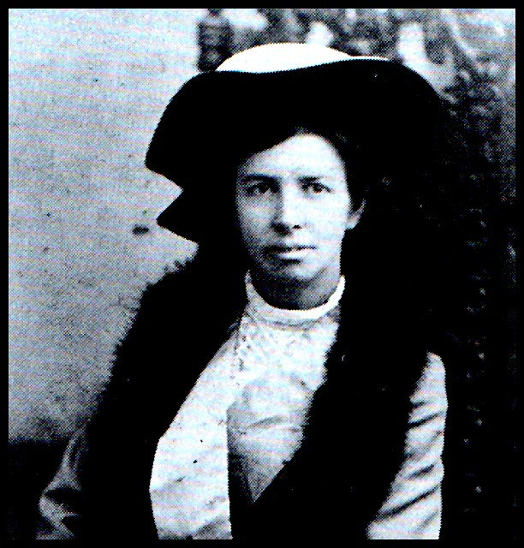

Mrs. Loulie Mathews Gregory, wife of Dr. Louis Gregory, often gave talks at the New York City Bahá’í Center. She had become a Bahá’í in England and accompanied ‘Abdu’l-Bahá on His voyage to America.

