A Maronite Physician's Encounter with ‘Abdu’l-Bahá in ‘Akká
By Boris Handal
2021 (updated 2022)
Shakir El Khoury

Dr Shakir El-Khoury (1847-1919) from Mount Lebanon was briefly a municipal physician in ‘Akká in the 1870s. He began his studies in Cairo’s medical school established in 1827 by Mohammad Ali but graduated at the Jesuit University of Beirut in 1874. Dr Shakir El-Khoury was a Christian Maronite and a long standing professor at the Jesuit Catholic University of Beirut. His autobiography entitled “Majma’ al-Masarrat” (The Collection of Joys”) in Arabic is available online on https://ia800204.us.archive.org/8/items/majmaalmasarrt00khrsuoft/majmaalmasarrt00khrsuoft_bw.pdf
In his autobiography, Dr Shakir El-Khour (p. 322) wrote the following about his meeting with ‘Abdu’l-Bahá in ‘Akká:

“’Akká now is part of a Province under the Turkish Administration, the city walls are still there and it is forbidden to erect any buildings close to it. Criminals were sent to ‘Akká, to the famous rigid prison if they were required to serve over five years in jail.
Bahá'u'lláh, a great man was exiled from Persia to Akka. He was the head of the Babis and originated from Persia.
When I visited ‘Akká, Bahá'u'lláh was living in the house of a rich merchant named Mr. Khamar’s. Only His closest friends could see him. He would only leave his home to visit particular people. He would leave and return at night, covered from other.
It was said that he wrote a book about his believes and his religion. We did not read it.
Persians are coming from everywhere to pay their respect. His son was welcoming them on his behalf.
Abbás Effendi, his eldest son, was known for being well-spoken with a generous soul, gentle, with great knowledge and writing skills. His gatherings were conducted with respect and dignity. He welcomed people from all social classes, those known to him as well as strangers. They were discussing with him all fields of knowledge.
I have met him, listened to him, discussed several matters and he appeared highly convincing.
When Bahá'u'lláh passed away, he was buried in a special place outside the city where his followers could visit him.
Abbás Effendi succeeded his father.
Up to this day, Persians and non-Persians visit Bahá'u'lláh's grave as part of their religious rituals.
I have heard that an American Lady, a new believer, is preaching His teachings in America.
It is said that the number of followers and the new believers has hugely increased.
I do not know much at all about this faith to talk about it, but I can tell from the behavior of its followers that it is one of great virtues.”
(Translated from the Arabic by myself, with the assistance of Mr and Mrs Mohsen and Bahia Zein.)
Here is a picture of the relevant text of his auto-biography (see also at archive.org/details/majmaalmasarrt00khrsuoft ):

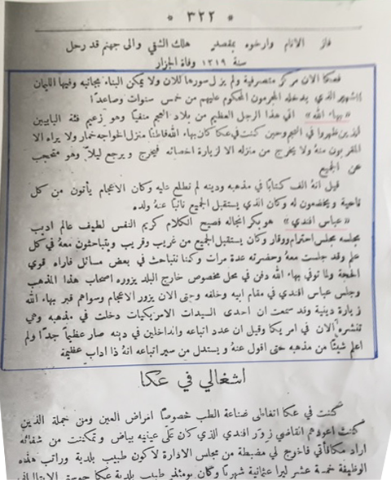

‘Udi Khammar (see The Revelation of Bahá'u'lláh, vol. 3, p. 220)

